**DATA ANALYTICS LAB**

|  |  |
| --- | --- |
| Exercise 2 | |
| Name | S Shyam Sundaram |
| Registration Number | 19BCE1560 |
| Slot | L33+L34 |
| Faculty | Dr. B Radhika Selvamani |
| Date | 23rd August, 2021 |

**AIM**

Working with array data type in R.

**QUESTION 1**

Create 2 atomic vectors v1, and v2. V1 has 3 elements and v2 has 6 elements. How can you create an array of dimension 3x3x2?

**CODE**

v1<-c(1,2,3)

v2<-c(4,5,6,7,8,9)

arr<-array(c(v1,v2),dim=c(3,3,2))

arr

**OUTPUT**

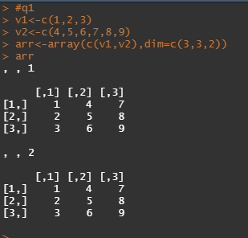

**QUESTION 2**

For the R objects given in the below code add the dimension names rname, cname and mname and convert them into a 3x3x2 array

**CODE**

r.names<-c("rname1","rname2","rname3")

c.names<-c("cname1","cname2","cname3")

m.names<-c("mname1","mname2")

v1<-c(1,2,3,4,5,6,7,8,9)

v2<-c(10,11,12,13,14,15,16,17,18)

arr<-array(c(v1, v2),dim=c(3,3,2),dimnames=list(r.names,c.names,m.names))

print(arr)

**OUTPUT**

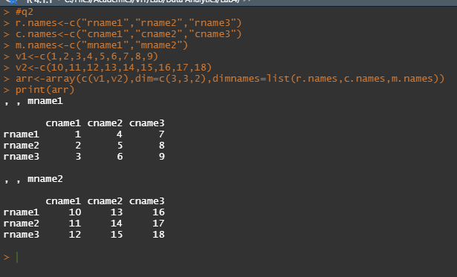

**QUESTION 3**

For the 3x3x2 array created in the previous solution print the following

a. Print the second row of the second matrix 1

b. Print the second column of first matrix 1

c. Print the element in the 2nd row and 3rd column of second matrix

d. Print the second matrix 1

**CODE**

#q3

#a

arr[2,,1]

#b

arr[,2,1]

#c

arr[2,3,2]

#d

arr[,,2]

**OUTPUT**

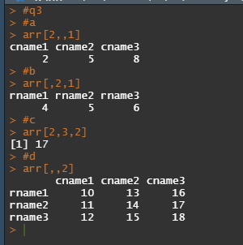

**QUESTION 4**

Split the 3x3x2 array A1 generated in the previous solution in to two 3x3 matrices M1 and M2. Calculate M3 to be sum of M1 and M2. Sum all elements of M1 and M2. Sum all elements of A1 and find its mean.

**CODE**

M1<-matrix(arr[,,1],nrow=3,byrow=TRUE)

M1

M2<-matrix(arr[,,2],nrow=3,byrow=TRUE)

M2

M3<-M1+M2

M3

mean(M3)

**OUTPUT**

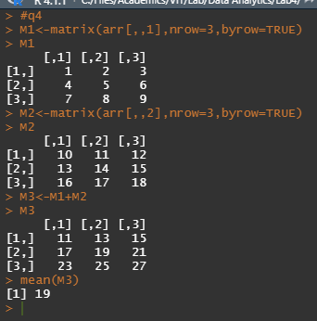

**QUESTION 5**

Create the following matrix, which stores the name and suit of every card in a royal flush. 1 ## [ ,1] [ ,2] 2 ## [1 ,] " ace " " spades " 3 ## [2 ,] " king " " spades " 4 ## [3 ,] " queen " " spades " 5 ## [4 ,] " jack " " spades " 6 ## [5 ,] " ten " " spades ".

**CODE**

face<-c("ace","king","queen","jack","ten")

suit<-c("spades","spades","spades","spades","spades")

flush<-matrix(c(face,suit),nrow=5)

flush

**OUTPUT**

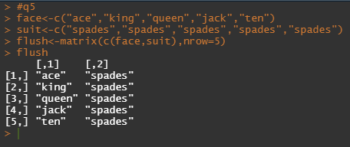

**QUESTION 6**

Many card games assign a numerical value to each card. For example, in blackjack, each face card is worth 10 points, each number card is worth between 2 and 10 points, and each ace is worth 1 or 11 points, depending on the final score. Make a virtual playing card by combining “ace,” “heart,” and 1 into a vector. What type of atomic vector will result? Check if you are right.

**CODE**

card<-c("ace","heart",1)

card

typeof(card)

**OUTPUT**

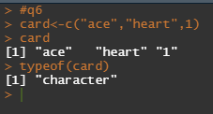

The vector will consist of character data type. As the first two elements are characters, the third element, 1, will also get converted to a character.

**CONCLUSION**

Thus, we have worked with the array data type and matrices in R.